# Two Weeks in South Korea

*By Maurin Aaron Dietschi*

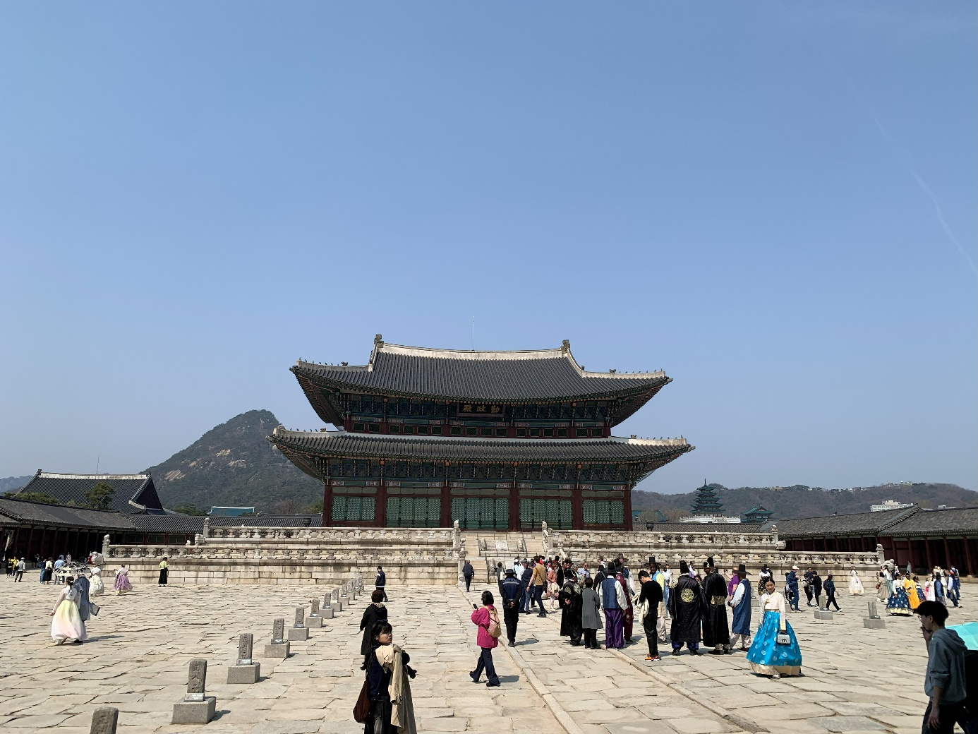

South Korea had been on my travel list for a long time. I’d always been fascinated by its mix of old and new — ancient palaces next to neon-lit gaming cafés, the smell of street food drifting through modern city streets, and the rhythm of a culture that feels both futuristic and deeply traditional.

This spring, I finally spent **two unforgettable weeks** traveling through the country with a friend — from **Seoul’s bustling neighbourhoods** to **Gyeongju’s historic treasures**, **Busan’s coastal charm**, and **Jeonju’s traditional beauty**.

This blog tells the story of that trip:

* what we did
* what we ate
* where we stayed
* and the small moments in between

At the same time, I hope it can serve **as inspiration and a practical reference** for anyone planning their own journey through South Korea.

## How to Use This Blog

This post is structured as a **day-by-day itinerary**, but you don’t have to follow it exactly.

You can:

* **Follow the full two-week route** (Seoul → Gyeongju → Busan → Jeonju → Seoul)
* **Pick single cities** (e.g. just Busan or just Jeonju) and use the relevant days
* Use the **“Things to do” / “Where to eat”** sections to build your own schedule

## Trip Snapshot

**Duration:** 14 days  
**Route:** Seoul → Gyeongju → Busan → Jeonju → Seoul  
**Best for:** Young adults (20–30) who want a mix of culture, food, nightlife, gaming, and history

#### Rough structure:

* **Days 1–5:** Seoul (Insadong, Myeongdong, Hongdae, Gangnam, Seongsu)
* **Days 6–7:** Gyeongju (history + temples)
* **Days 8–9:** Busan (coastlines + culture)
* **Days 10–11:** Jeonju (hanok & food)
* **Days 12–13:** Seoul again (Hongdae & quiet corners)
* **Day 14:** Departure

#### Budget:

South Korea is not the cheapest place on earth, but as a Swiss person, it definitely feels cheaper compared to Switzerland. You can get a very good dinner for about **5–10 CHF**, including drinks. I spent about **700 CHF** for two weeks in South Korea, which amounts to roughly **1,277,698 won**. I paid around **1,053 CHF** for direct flights with Korean Air, and **600 CHF** for all the hotels.

So my total expenses for these two weeks were around **2,500 CHF** — and that was with a very comfortable lifestyle.

#### When to visit:

We went in April, and I would highly recommend it because of the mild temperatures — usually around **15–25°C** — and the overall pleasant weather. I would discourage visiting in the peak summer months because of the heat and humidity. That said, every season in South Korea has its own charm and atmosphere.

#### Transportation:

I recommend buying a **T-Money card** at the start of your trip. It works for almost all buses and metros, and you can get one in most convenience stores. If you need to catch a bullet train (KTX) from Seoul to Busan, the best option is to go to the station one day before your trip and buy the ticket at the counter.

For navigation, use **Google Maps** and **Kakao Maps** — I recommend using both because they sometimes show different routes. Public transport can take you almost everywhere, and taxis are also available, although they are not always the cheapest option.

**Our train times with the KTX (bullet train):**  
• Seoul Station → Gyeongju Station: **2 h 20 min**  
• Gyeongju Station → Busan Station: **30 min**  
• Busan Station → Jeonju Station: **2 h 58 min**  
• Jeonju Station → Seoul Station: **1 h 59 min**

# Day-by-Day Itinerary

## Day 1 – Arriving in Seoul

We landed at **Seoul Incheon Airport** around 2 p.m. and caught a train to our hotel in **Insadong**, a very central area of Seoul that is still relatively quiet. It’s a great base because it’s close to historic sights like **Gyeongbokgung Palace**, and not too far from **Myeongdong**, which is busy and full of life day and night.

That afternoon and evening, we explored **Myeongdong’s** alleys, tried **Korean BBQ**, and ended the night in a small local bar. The energy of the city hit us instantly — loud, colourful, and alive.

💡 **Things to do in Myeongdong:**

* Wander the packed streets full of **street food stalls and shops**
* Explore Korean **skincare and beauty stores**
* Visit the **Myeongdong Cathedral**

🍜 **Where to eat:**  
Myeongdong Korean BBQ All You Can Eat Pig Company  
<https://maps.app.goo.gl/U3ogKAT2Y1DwfTrR8>

🏨 **Where we stayed:**  
Hotel Prima Seoul: *The hotel was very good — modern rooms, friendly staff, and even a coin laundry for our dirty clothes. The location was superb, so I would highly recommend it.* -<https://maps.app.goo.gl/3ScAyv6894m8syxZ8>

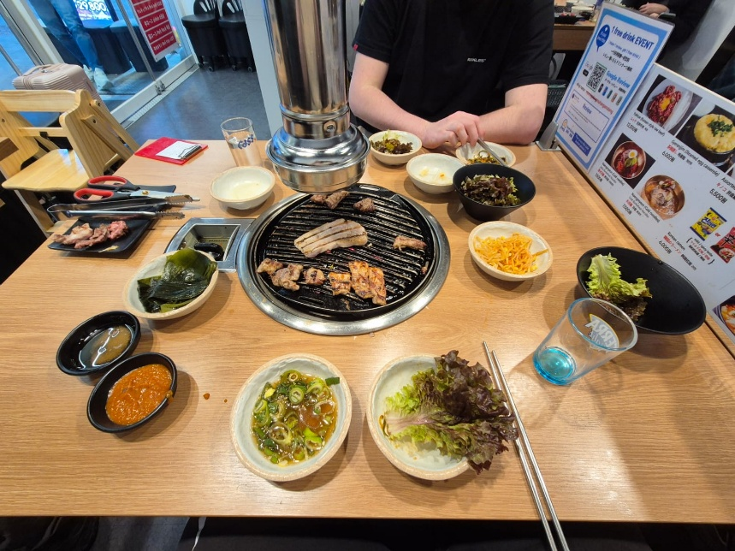

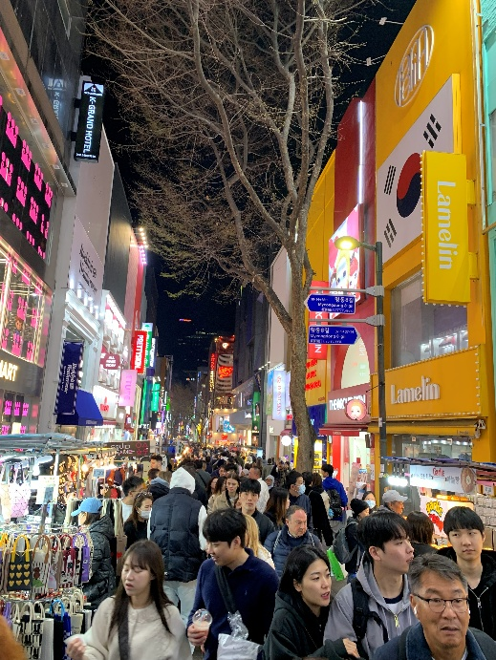

## Day 2 – Palaces and Hanok Villages

We started the morning exploring **Bukchon Hanok Village**, a neighbourhood full of traditional Korean houses between **Gyeongbokgung** and **Changdeokgung** Palaces. Walking there felt like time-travel — from modern streets to old alleys and tiled roofs.

Even though it’s a cool place to visit, I was slightly disappointed. It felt more like a regular neighbourhood than the fully “traditional” atmosphere I had expected, but it was still worth seeing.

Later, we visited **Gyeongbokgung** and **Changdeokgung** Palaces, learning about Korea’s royal history and architecture. You can stroll around quite freely and there’s a lot of information to take in — from the **Japanese occupation** to the development of the palace complexes. There, you can also witness a traditional reenactment of the **Joseon Dynasty’s royal guard-changing ceremony**. Entry tickets cost 3’000 Won each.

In the afternoon, we went to the **T1 Basecamp in Hongdae**, an esports center popular among gaming enthusiasts. We had a light lunch, played a few matches, and enjoyed the vibrant atmosphere of the esports community.

Later, we explored the **Insadong** area near our hotel and discovered a hidden gem of a restaurant — **Insadong Maneul Bossam**. They served traditional set meals with **Bossam** (boiled pork belly) and **spring onion pancakes**, which were absolutely delicious. Paired with a savoury **chestnut makgeolli**, it was the perfect way to end the evening.

💡 **Things to do:**

* Visit **Gyeongbokgung** and **Changdeokgung** Palaces (must-sees for first-time visitors)
* Walk through **Bukchon Hanok Village**
* Experience Korean gaming culture at **T1 Basecamp** in Hongdae

🍜 **Where to eat:**  
Insadong Maneul Bossam  
<https://maps.app.goo.gl/KGZHH59qE1Wk343e7>

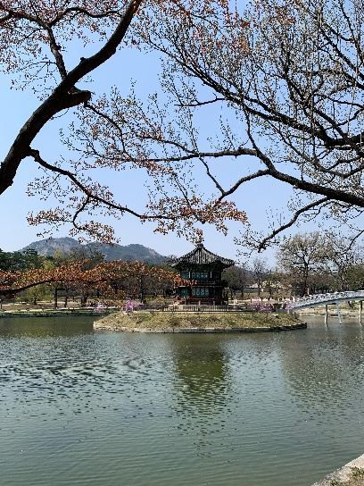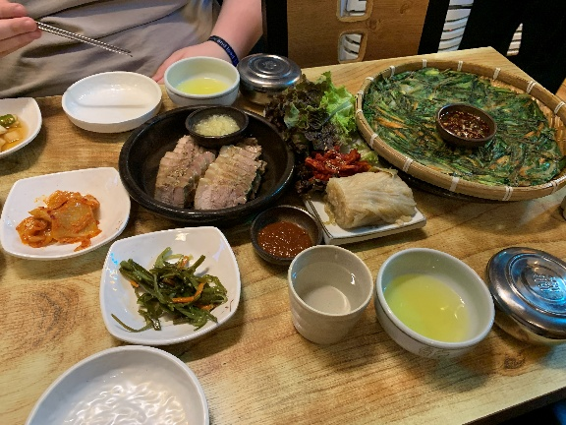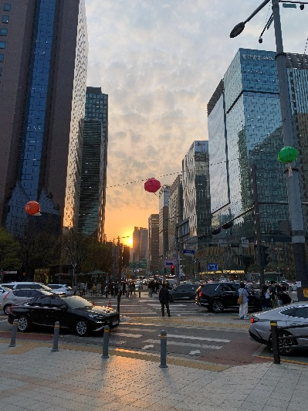

## Day 3 – The DMZ Experience and Yeouido Hangang Nights

Our third day was something completely different: the **DMZ Tour** near the North Korean border. It was an emotional and educational experience — learning about the history and tension between the two Koreas left a deep impression. We took a guided tour from **GetYourGuide**, which I highly recommend.

Back in Seoul, we relaxed at **Yeouido Hangang Park**, where a **street food festival** was happening. Locals picnicked by the river, couples biked past, and live music played as the sun set. We ate **corn dogs, tteokbokki, fried chicken**, and for dessert some delicious **hotteok**.

💡 **Things to do:**

* DMZ Tour:  
  <https://www.getyourguide.de/seoul-l197/seoul-dmz-tour-mit-optionaler-hangebrucke-t63099/>
* Yeouido Hangang Park
* Banpo Bridge Moonlight Rainbow Fountain

🍜 **What to try:**

* Korean corn dog
* Tteokbokki (spicy rice cakes)
* Korean fried chicken
* Hotteok (sweet pancakes)

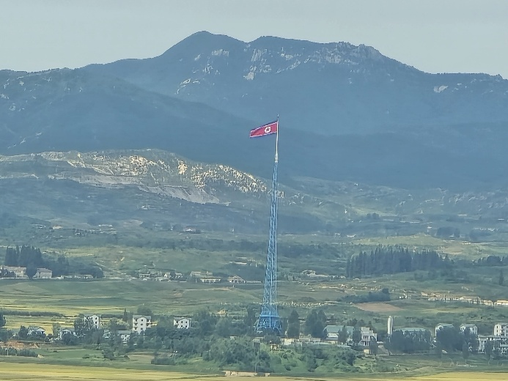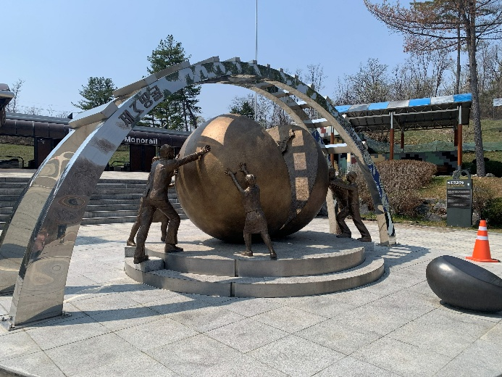

## Day 4 – Namsan Hike & Seongsu Exploration

We hiked up to **N Seoul Tower** in the morning. The trail was calm and green, offering amazing views once we reached the top. We grabbed a quick breakfast at **Starbucks** in the tower and used the time to plan the rest of our day.

Afterwards, we walked back through the **Namsan Botanical Garden**, enjoyed the relaxed atmosphere, and even chatted with a Korean grandpa about Seoul. Then we took the subway towards **Seongsu**.

Seongsu is full of indie cafés, art shops, and street murals. We had lunch at **Seongsu Darak**, explored **Seoul Forest Park** full of cherry blossoms and the deer corral, and then went shopping for some vintage clothing (which was a bit challenging for my rather large build). We ended the day with ramen at **Nirou Mian Guan**, a place with multiple **Michelin awards**.

💡 **Things to do:**

* Walk through the forest up to **N Seoul Tower**
* Explore the **Seongsu** area: cafés, shops, Seoul Forest

🍜 **Food spots:**

* **Seongsu Darak** – <https://maps.app.goo.gl/fKH4BTJLj1hHV5Zq7>
* 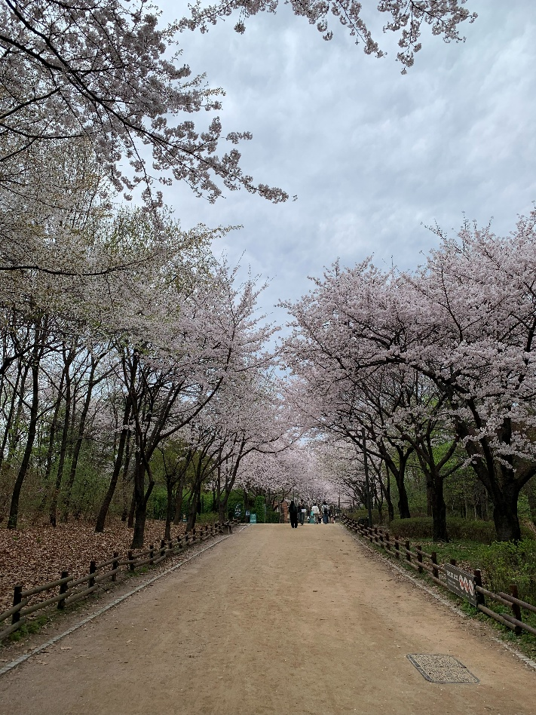**Nirou Mian Guan** – <https://maps.app.goo.gl/XHMqaaE3Z9a5SeUS6>

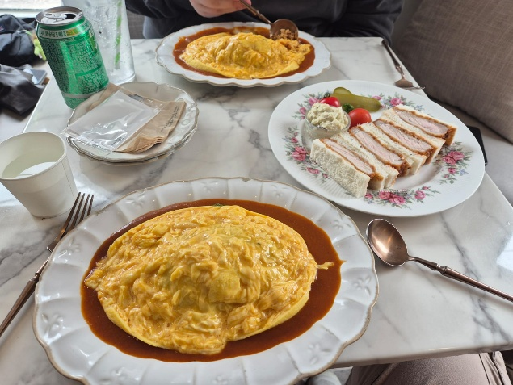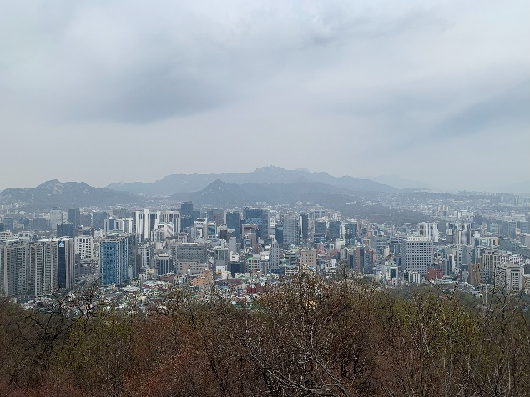

## Day 5 – Gangnam Style: Temples & Tombs

We spent the day in **Gangnam**, Seoul’s modern and stylish district. After a late breakfast at **Cheonsang Gaok**, where we enjoyed their delicious salt bread. We decided to skip lunch.

The contrast throughout the day was striking: we began at **Bongeunsa Temple**, a serene space surrounded by skyscrapers, lush nature, and an impressive standing Buddha statue. We then visited the **Starfield Library** inside the COEX Mall — a dreamlike place for book lovers — and made a quick stop at the **Gangnam Style statue**, an iconic photo spot just outside the mall.

In the afternoon, we walked through the **Seolleung and Jeongneung Royal Tombs**, a peaceful and green historic site hidden in the middle of the city. For dinner, we went to **Oncheonjip**, a restaurant well known for its excellent **shabu shabu**.

💡 **Things to do in Gangnam:**

* **Bongeunsa Temple**
* **Starfield Library** (COEX Mall)
* **Seolleung and Jeongneung Royal Tombs**

🍜 **Where to eat:**

* **Cheonsang Gaok** – <https://maps.app.goo.gl/YTzYA8UWrSp6kcSp7>
* **Oncheonjip** – <https://maps.app.goo.gl/dUoMaSLXPRpnYuKu8>

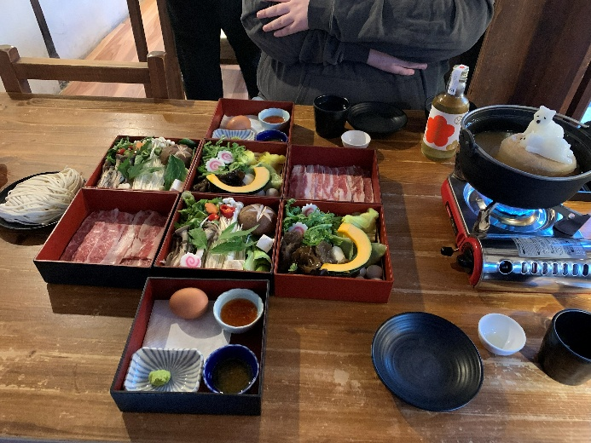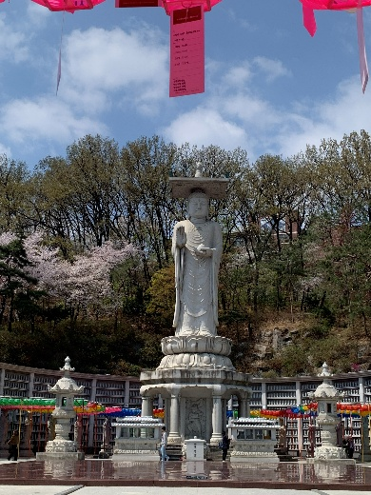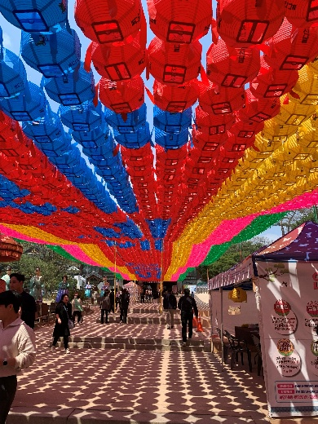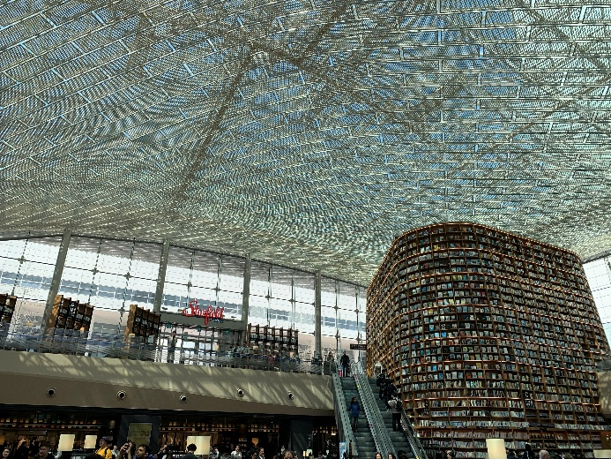

## Day 6 – History Comes Alive in Gyeongju

Early in the morning, we took the train to **Gyeongju**, often called Korea’s “museum without walls.” The city is full of historical treasures.

We began at the **Gyeongju National Museum**, which presents Korea’s history from the **Bronze Age** to the **Unified Silla period**, displaying ancient artifacts, statues, and massive ceremonial bells.

We continued to **Banwolseong**, a forested archaeological site where many ancient artifacts have been discovered. This area includes the remains of the old Silla fortress and offers a peaceful walk through nature.

Another stop was **Cheomseongdae Observatory**, one of Korea’s most famous historic landmarks. Surrounded by flower fields, it looks almost like a giant stone furnace rising from the ground.

We also explored the **Tomb of King Michu of Silla**, part of a royal burial complex from the Silla era. You can even enter one of the tombs to see the interior structure, which was incredibly impressive.

Later, we saw **Woljeonggyo Bridge**, which was another highlight of the day. We also visited this in the evening, and I can only recommend it — the bridge glows beautifully in the shimmering lights, creating a perfect photo spot. You can even cross the river on stepping stones and admire the view from below.

From there, we visited **Wolji Pond**, known for its beautiful pavilions, pagodas, and surrounding nature. I especially recommend visiting in the evening — the entire area is illuminated in a mysterious, atmospheric light accompanied by soft music.

It was one of my favourite days — a perfect blend of nature, history, and culture.

💡 **Must-sees in Gyeongju:**

* Gyeongju National Museum
* Wolji Pond
* Woljeonggyo Bridge
* Tomb of King Michu of Silla

🍜 **What to eat:**  
Yangbanjib – <https://maps.app.goo.gl/DdzKmKHMTaWnjcFr6>

🏨 **Where we stayed:**  
Yettle Hanok Stay: *The hanok was fantastic — the owner helped us plan our two days in Gyeongju and even gave us a map to find our way around. It was comfortable, traditional, and I would highly recommend staying here.* - <https://maps.app.goo.gl/asRLp7rwJRpubiM48>

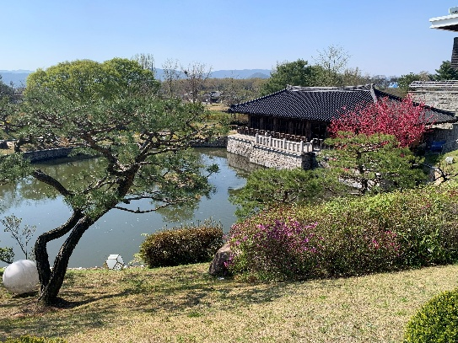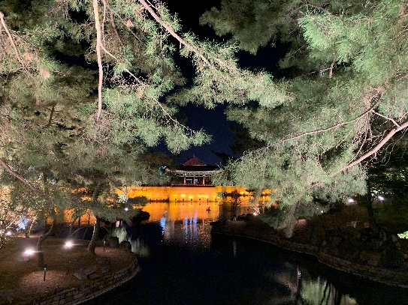

## Day 7 – Temples and Tranquility

We continued exploring Gyeongju with visits to **Bulguksa Temple** and **Seokguram Grotto**, both recognized as UNESCO World Heritage Sites. While you’re there, you can also try **Hwangnam-ppang**, a local Gyeongju specialty made from red bean paste and soft pastry.

To reach **Seokguram Grotto**, you can either take the shuttle bus up the mountain or walk the entire way. I highly recommend taking the bus up and then walking back down afterward — the trail is peaceful and offers beautiful views.

Later, we visited **Jungdo Tower**, which rises impressively over the surrounding village. Afterwards, we walked around the serene **Bomun Lake** and took a break at **Page 9 Café**, a perfect spot to rest and enjoy the view.

In the evening, we took the bus back to central Gyeongju. We wandered through the **Gyochon Traditional Village**, filled with restaurants, tea houses, and small shops — a great place to rest, eat, and explore traditional Korean culture. Then we had dinner at **Tiger Katsu**, a restaurant known for serving delicious Japanese-style pork katsu.

💡 **Things to do:**

* Bulguksa Temple
* Seokguram Grotto
* Bomun Lake

🍜 **Local cafés or restaurants:**

* Page 9 Café – <https://maps.app.goo.gl/jCyAqY6mtQkoKn9w6>
* 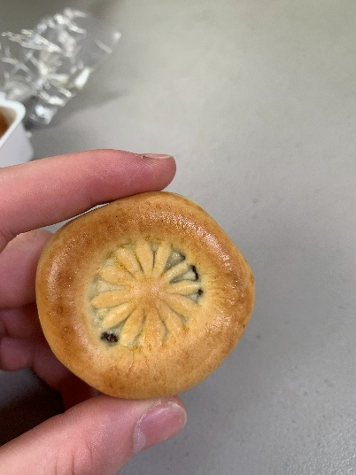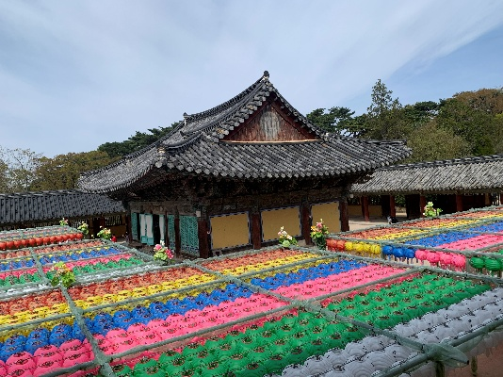Gyeongju restaurant Tigerkatsu – <https://maps.app.goo.gl/znCaL6PBoK5a5Sjx8>

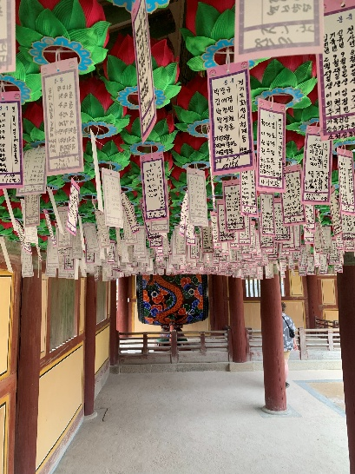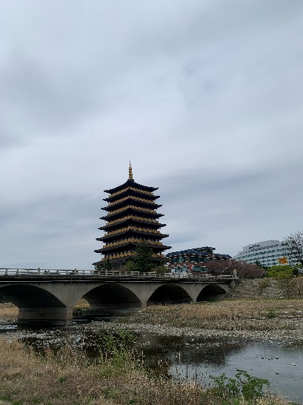

## Day 8 – Welcome to Busan

The next morning, we took the train to **Busan** and checked into our hotel in the **Sinchang-dong** district. We spent the first part of the day at **Haeundae Beach** and explored the nearby **Haeundae Traditional Market**, which was full of snacks and local specialties.

For a spectacular view of the coastline, we visited **Busan X the SKY** and went up to the **101st floor**, nearly 400 meters above ground. The panorama from up there was incredible.

Later, we rode the **Haeundae Blueline Park** train for stunning coastal views before heading to the **Haedong Yonggungsa Temple**. This temple is built directly on the cliffs overlooking the sea, making it one of the most unique temple settings in Korea.

In the evening, we returned to our district and had dinner at a traditional restaurant, where we enjoyed a comforting **kimchi stew**.

💡 **Things to do:**

* Haeundae Beach
* Busan X the SKY
* Haedong Yonggungsa Temple

🍜 **Where to eat:**  
**Sulodang** – <https://maps.app.goo.gl/znCaL6PBoK5a5Sjx8>

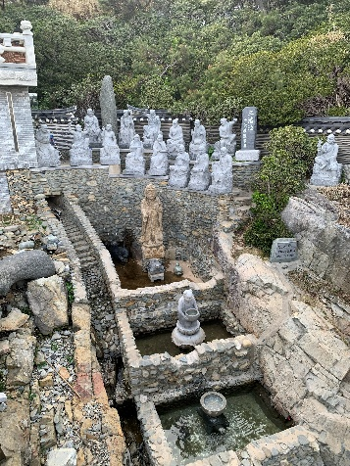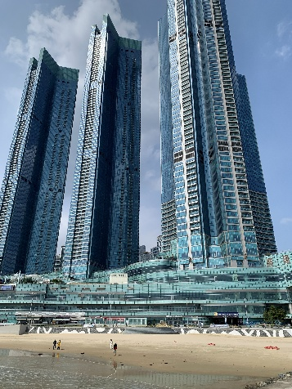🏨 **Where we stayed:**  
GNB Hotel: *The hotel was quite good — not exceptional, but in a convenient location and at a great price.* – <https://maps.app.goo.gl/wtsy4ZVYMHjmV7V56>

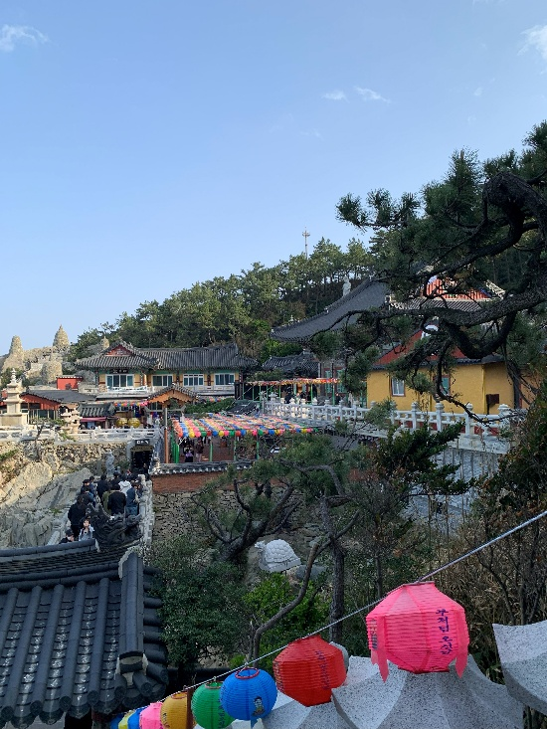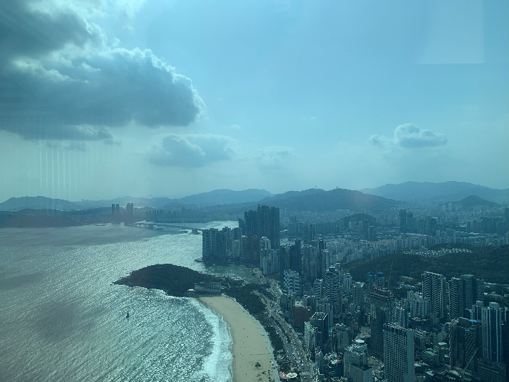

## Day 9 – Culture and Coastlines

The next day was all about culture and colour. We started early and took a bus to **Taejongdae Park**, where we spent the morning walking through nature and enjoying incredible views of the cliffs and the ocean. We also grabbed a few snacks near the lighthouse before heading back.

In the afternoon, we visited **Gamcheon Culture Village**, a place with a completely different atmosphere from the rest of Busan. It’s artistic, vibrant, and slightly chaotic in a way that feels both nostalgic and unique. We stopped at **DUF Coffee** for an iced latte during our walk, which was a great break in the middle of all the exploring.

Part of Gamcheon’s charm comes from its history — the village was shaped by families who settled there during difficult times, including refugees from the North, which gives the area a special cultural background.

In the evening, we went to **BIFF Square** and had **dakgalbi**, which ended up being one of my favourite meals of the entire trip.

💡 **Top tips:**

* Gamcheon Culture Village
* Taejongdae Park
* BIFF Square

🍜 **Cafés & Food:**

* **DUF Coffee** – <https://maps.app.goo.gl/G9pUrrPp4pvFkK6p7>
* 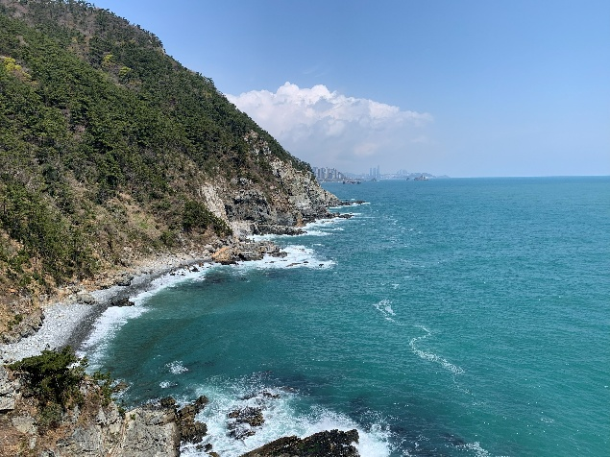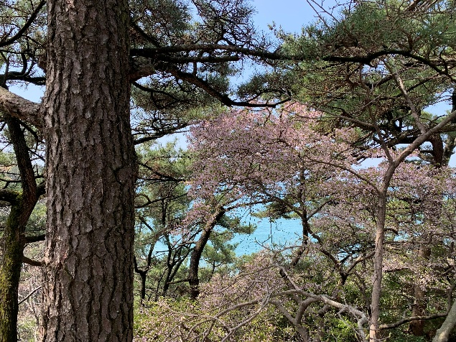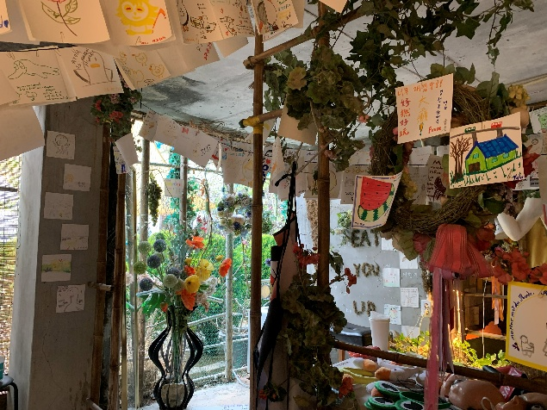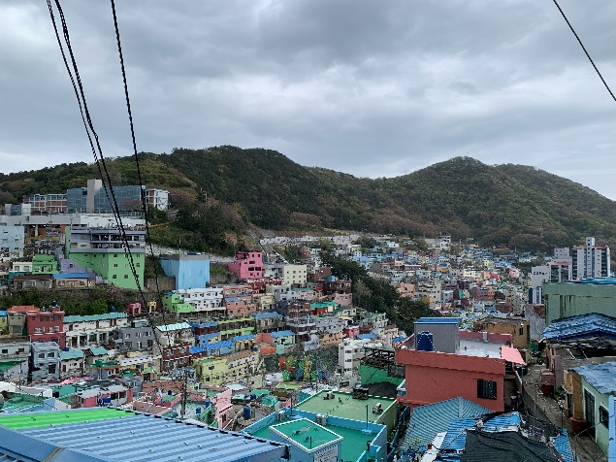**Dakgalbi** – <https://maps.app.goo.gl/JctqvaomjnCAEQZQ9>

## Day 10 – Jeonju’s Hanok Beauty

The next morning, we took the train to **Jeonju**, which took about two hours since there is no direct connection from Busan. Jeonju is famous for its **Hanok Village** and rich food culture, so we were excited to explore.

Our first stop was **Gyeonggijeon Shrine**, where you can walk around freely and enjoy the peaceful atmosphere and traditional architecture. For lunch, we tried a viral spot called **Goof-Off**, known for its **Italian–Korean fusion dishes**, which turned out to be surprisingly good.

In the afternoon, we visited **Jeondong Cathedral** and **Nambu Market**, then wandered through streets filled with people wearing traditional **hanbok**, which gave the whole area a lively and festive feeling.

For dinner, we chose a small, very traditional family-run restaurant. It was just a father, mother, and their daughter running the place — and they served some truly delicious home-style cold noodles.

💡 **Things to do in Jeonju:**

* Gyeonggijeon Shrine
* Walk through the Hanok Village
* Explore Nambu Market

🍜 **Must-eats:**

* **Goof-Off** – <https://maps.app.goo.gl/BkbjjCzrdCq2x1zw5>
* **Ucheon Kudzu** – <https://maps.app.goo.gl/u5SF3QRZaJHJ5L5a8>

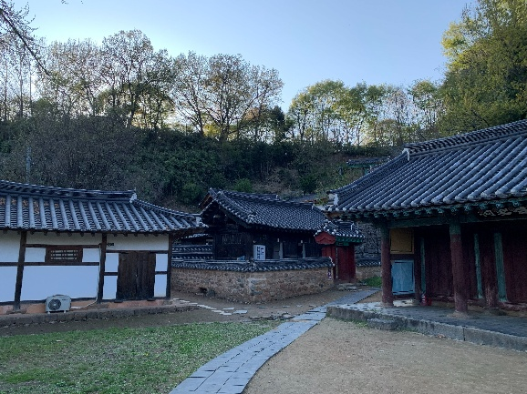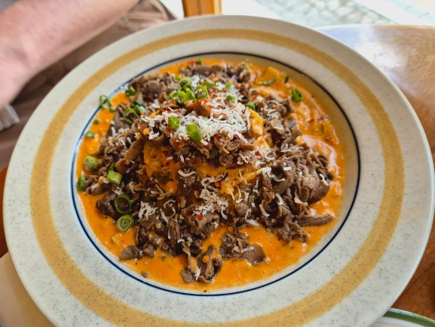🏨 **Where we stayed:**  
And Spring: The And Spring Airbnb was fantastic. It was quite small, but the location makes up for it, you can’t be more in the centre of Jeonju. Since you won’t spend much time in the room anyway, it’s perfect. I highly recommend this place. – <https://maps.app.goo.gl/xpRnLuGZLRqTt1xRA>

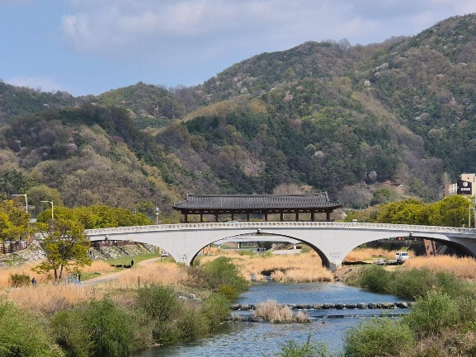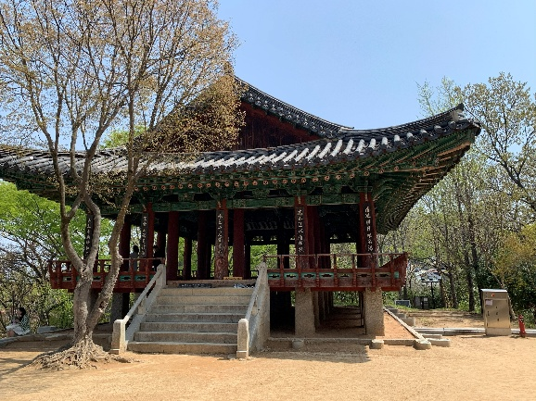

## Day 11 – Hikes and Hidden Corners

Today, we hiked **Gilinbong Mountain**, where the fresh air and peaceful nature made the climb incredibly enjoyable. From the top, you get a beautiful view over the **Hanok Village**, which feels especially unique from above.

After the hike, we explored the ruins of **Donggosanseong Fortress**. The site is quite large, and you can still see sections of the old walls scattered across the mountain, giving a strong sense of the area’s historical scale.

Later, we walked around **Ajung Lake** and relaxed with **matcha cheesecake** and an **iced matcha latte**. The matcha was sourced from **Jeju Island**, which made the experience even more special.

In the afternoon, we continued through **Jaman Mural Village** to **Omokdae**, a viewpoint that offers a closer look over the Hanok Village and surrounding scenery. Afterwards, we walked along the river and had a friendly conversation with some locals, who recommended a place for dinner.

Before eating, we stopped by **VIBRA**, a vintage shop where we found some great pieces. For dinner, we went to **Ondam**, a restaurant known for its premium Korean pork BBQ — and it was absolutely fantastic.

💡 **Things to do:**

* Gilinbong Mountain
* Ajung Lake
* Jaman Mural Village & Omokdae

🍜 **Where to eat:**

* Ondam – https://maps.app.goo.gl/183yW7wUCcQVbDX97
* 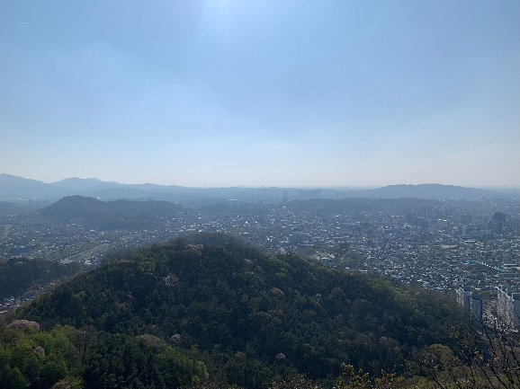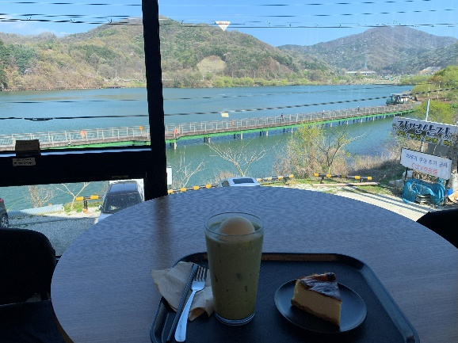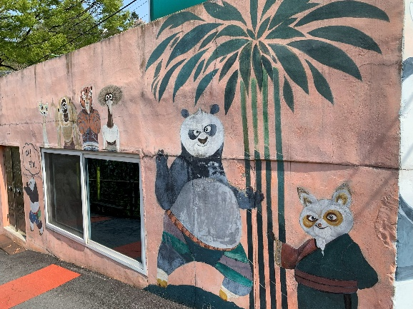Ajuleu - <https://maps.app.goo.gl/y8xUWASkMqJAjEat7>

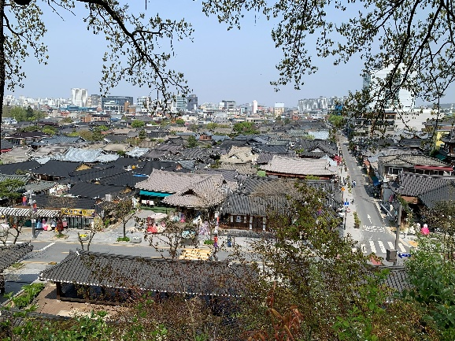

## Day 12 – Hongdae Nights

Back in **Seoul**, we explored **Hongdae**, an area known for its street performances, vibrant art scene, and lively nightlife. We also visited **Haneul Park**, famous for its vast open fields and panoramic views over the city.

For lunch, we stopped by a **Michelin Guide–listed ramen restaurant**, which was absolutely outstanding. Afterwards, we spent some time walking along the **Hongdae Shopping Street**, browsing the shops and soaking up the energetic atmosphere.

In the evening, we joined a **pub crawl** and met new friends — **Lydia from Taiwan** and **Bruno from the Netherlands**. We visited four different clubs and bars together and ended up dancing until 3 a.m.

💡 **Things to do in Hongdae:**

* Hongdae Shopping Street
* Haneul Park
* Pub crawl / nightlife

🍜 **Evening eats & drinks:**

* Dokkaebi Party House – <https://maps.app.goo.gl/sb7zy4tTXA6fvfHx9>
* KB2 – <https://maps.app.goo.gl/NPEho4H86khzhZ6J9>
* La Bamba – <https://maps.app.goo.gl/1ohSFu9bguVshowH8>
* Playground Pub – <https://maps.app.goo.gl/ijrRBbimYcQugEzQA>
* Oreno Ramen – <https://maps.app.goo.gl/PSAuMoibAHH9Rgcq5>

🏨 **Where we stayed:**  
Arirang Hill Hotel Dongdaemun: The hotel was excellent — friendly staff and a surprisingly large room for Seoul. The only downside was the location, which wasn’t within walking distance of most places I wanted to visit. However, with a metro station right around the corner, it wasn’t a big issue. – <https://maps.app.goo.gl/an8w6jeyEH1jTySBA>

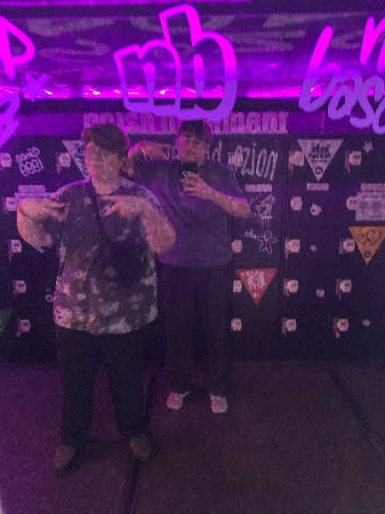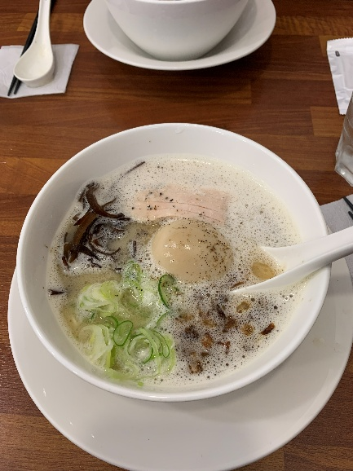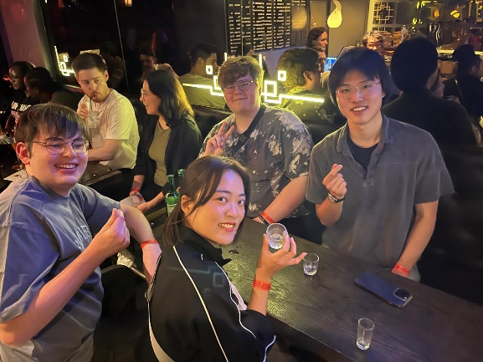

## Day 13 – Calm Corners of Seoul

After a late morning, I visited the **Cheongun Literature Library** and the **Hill of Poet Yun Dong-ju** — quiet, reflective places that reveal a calmer and more contemplative side of the city. Near these two sights, there is an art museum that blends traditional and modern styles. **Seokpajeong** features impressive works of art as well as a beautiful garden and a small temple area at the top.

Afterwards, I took the bus to **Café Pokpo**, which offers a variety of drinks and snacks. The highlight is the view: you can sit outside and watch the waterfall flowing directly behind the café.

I finished the day gaming with **Bruno** at the **T1 Base Camp**. Bruno had an account that allowed us to play on the Korean server — something usually not possible due to South Korean gaming regulations — which made the experience even more fun and unique.

Later in the evening, I met **Lydia** for dinner, and we enjoyed some incredible **soba noodles** together.

💡 **Things to do:**

* Cheongun Literature Library
* Seokpajeong
* Café Pokpo

🍜 **Where to chill:**

* Cafe Pokpo – <https://maps.app.goo.gl/mUp37LhHWGy5aDjYA>
* Kandasoba Hongdae - <https://maps.app.goo.gl/BJRgrVQ8CaxqQDqr9>

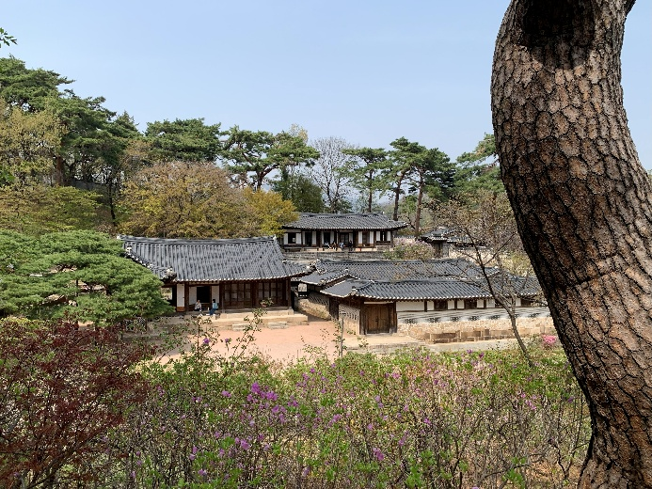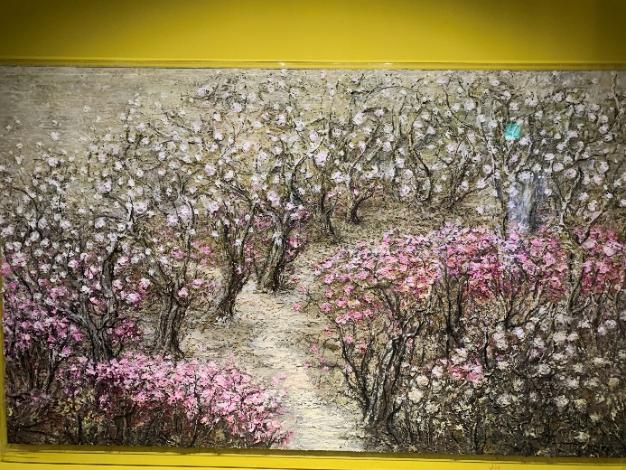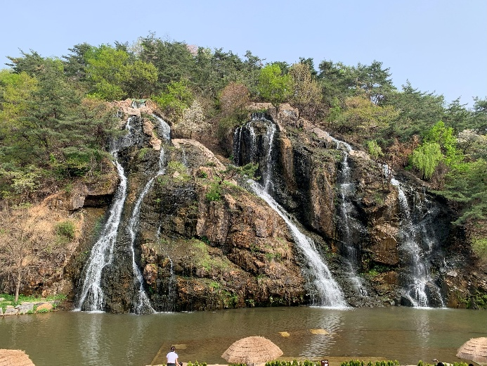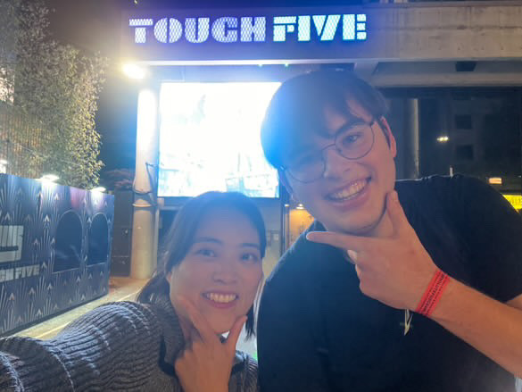

## Day 14 – Farewell

We almost missed our flight to Zurich because we overslept — classic. With some quick thinking and a taxi driver who must have been secretly training for Formula 1, we made it to **Incheon Airport** just in time. We were so late that we couldn’t even check in our luggage, so we had to drag everything through security. I ended up losing a few souvenirs and my razor blades, which security definitely didn’t appreciate.

Still, we somehow reached the gate with only five minutes left before boarding. Completely out of breath and sweating, we collapsed into our seats as the plane took off. Watching Seoul shrink beneath the clouds, it hit me how much these two weeks meant.

**South Korea isn’t just a place you visit — it’s a place that stays with you.**

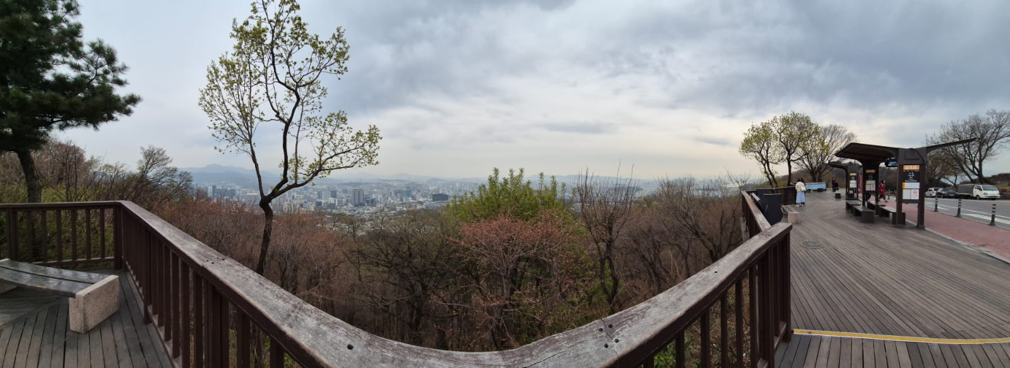

## Final Thoughts

These two weeks in South Korea combined everything I love about travel:

* **History and culture** that you can feel in the streets
* **Food** that you still think about months later
* **People and moments** that turn into stories you keep telling

If you’re in your twenties, curious about East Asia, and open to mixing **palaces, gaming cafés, beaches, bars, temples, and street food**, South Korea is the perfect place to start.

If I had more time, I would have invested 1 week on Jeju Island, visiting the mountains and the Beaches. Aside from that, i would also have liked to have more time in Seoul, so I could do some daytrips from there.

If you’re in South Korea for the first time, I would recommend staying flexible — things will never go exactly as planned, so just walk around, explore, and let things happen naturally. And be sure to have some cash on you: most places accept card, but some remote shops only accept cash.